***A Report on Biometric Attendance System***

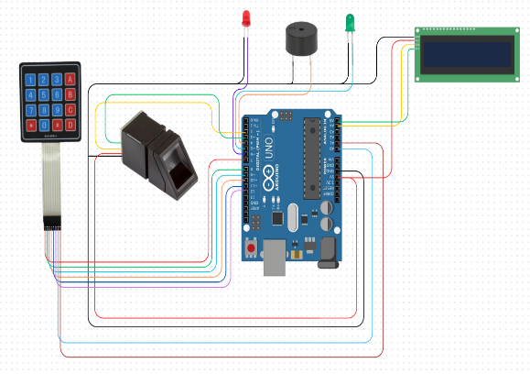

**R&D Projects**



**PHN Technology Pvt. Ltd.**

**ABSTRACT**

**Abstract:**

This project presents a Biometric Attendance System using an Arduino Uno, fingerprint sensor, 16x2 LCD with I2C module, two LED indicators, and a buzzer. The goal is to design a secure and automated method for recording attendance based on fingerprint recognition. Upon successful fingerprint authentication, the system provides visual (LEDs and LCD) and audio (buzzer) feedback to indicate the status of the authentication.

In today's modern world, biometric authentication systems are rapidly replacing traditional attendance methods. The system developed here uses fingerprint recognition to improve reliability and reduce the chances of proxy attendance. It is a cost-effective solution using widely available electronic components. The project not only introduces students and developers to microcontroller interfacing and biometric modules but also encourages the design of more secure embedded systems. The simplicity of the Arduino platform and the flexibility of components used make it an excellent learning tool while achieving practical utility in real-world scenarios.

**TABLE OF CONTENTS**

|  |  |
| --- | --- |
| **DESCRIPTION PAGE**  **Chapter 1: Introduction ................................................................................................................** | **NUMBER**  **1** |
| 1.1 **Background of the Project** .......................................................................................... | 1 |
| 1.2 **Problem Statement** ..................................................................................................... | 2 |
| 1.3 **Objectives of the Study** .............................................................................................. | 3 |
| 1.4 **Scope of the Project** .................................................................................................... | 4 |
| 1.5 **Organization of Chapters** .......................................................................................... | 5 |
| **Chapter 2: Literature Review ......................................................................................................** | **6** |
| **Chapter 3: Design and Implementation .....................................................................................** | **8** |
| 3.1 **Materials Used** ................................................................................................................... | 8 |
| 3.1.1 **Microcontroller (Arduino uno)** .......................................................................... | 8 |
| 3.1.2 **Sensors (buzzer,led) ………………..**....................................................................... | 9 |
| 3.1.3 **display……………………………………** ............................................................... | 10 |
| 3.2 **Circuit Design & Working Principle** ............................................................................... | 11 |
| 3.3 **Software & Programming** ................................................................................................ | 12 |
| 3.4 **Mechanical Structure** ....................................................................................................... | 13 |
| **Chapter 4: Implementation & Testing .......................................................................................** | **15** |
| 4.1 **Sensor Calibration** ..................................................................................................... | 15 |
| 4.2 **Navigation & Fire Suppression Testing** ................................................................... | 16 |
| 4.3 **Wireless Communication & Monitoring** ................................................................. | 17 |
| **Chapter 5: Challenges, Future Enhancements & Conclusion ................................................** | **18** |
| 5.1 **Challenges & Limitations** ......................................................................................... | 18 |
| 5.2 **Future Scope & Enhancements** ................................................................................ | 19 |
| 5.3 **Conclusion** .................................................................................................................. | 20 |

**Introduction**

* 1. **Background of the Project**

Manual attendance systems are prone to inaccuracies and fraud. With the growing need for biometric authentication, this project introduces a fingerprint-based attendance mechanism that ensures authenticity and automation using Arduino and other components.

**1.2 Problem Statement**

Traditional attendance systems are insecure, time-consuming, and susceptible to proxy attendance. The need for a reliable and tamper-proof method like fingerprint recognition is crucial for environments like schools, offices, and secured facilities.

**1.3 Objectives of the Study**

* **To develop a fingerprint-based attendance system using Arduino Uno.**
* **To provide real-time visual and audio feedback using LEDs, buzzer, and LCD.**
* **To enhance security by using biometric authentication.**
* **To store and verify fingerprints reliably using a fingerprint sensor.**

**1.4 Scope of the Project**

This project aims to deliver a small-scale prototype of an attendance system using fingerprint scanning. It ensures real-time feedback and can be scaled with memory and database integration for long-term data storage.

**1.5 Organization of Chapters**

* **Chapter 2: Literature Review**
* **Chapter 3: Design and Implementation**
* **Chapter 4: Implementation & Testing**
* **Chapter 5: Challenges, Future Enhancements & Conclusion**

**Literature Review**

**2.1 Introduction**

Biometric-based attendance systems have grown significantly in popularity due to their reliability and security compared to traditional methods. Fingerprint recognition, a widely used biometric trait, ensures that the person marking attendance is physically present. With the availability of microcontrollers like Arduino and components such as fingerprint sensors, LCDs, and buzzers, it has become feasible to build cost-effective biometric systems. This chapter explores various biometric attendance technologies, the role of fingerprint sensors, and how Arduino platforms have contributed to simplified development and implementation.

**2.2 Existing Bluetooth-Controlled Robots**

Numerous fingerprint-based attendance projects have been implemented using various combinations of hardware and software. Some notable examples include:

* **Arduino-Based Fingerprint Systems**: These systems use sensors like R305 or GT-511C3 with Arduino Uno to authenticate users and provide real-time feedback using LEDs and buzzers.
* **Commercial Biometric Devices**: Devices from brands like ZKTeco and ESSL incorporate biometric sensors with databases to offer advanced features such as Wi-Fi connectivity and cloud integration.
* **Raspberry Pi-Based Attendance Monitors**: These leverage Linux-based programming and larger databases to manage attendance in institutional environments.

**2.3 Biometric Sensors and Authentication Modules**

Fingerprint sensors are the core of these systems and are responsible for acquiring, processing, and matching fingerprints. Common modules include:

* R305 Fingerprint Sensor: Popular for Arduino applications, it supports fingerprint enrollment, image capture, and matching stored templates.

**2.4 Arduino Microcontroller Integration**

Arduino Uno plays a crucial role in interfacing between input (fingerprint sensor) and output devices (LEDs, LCD, buzzer). It executes logic based on sensor input and activates peripherals accordingly. Features include:

* Open-source Ecosystem: Easy to use with a vast collection of libraries.
* Multiple I/O Pins: Supports simultaneous connection of LCD, sensor, LEDs, and buzzer.
* Compact and Affordable: Suitable for small-scale or educational projects.

Libraries such as Adafruit Fingerprint simplify communication with biometric modules.

**2.5 User Feedback Mechanisms**

For a smooth user experience, real-time feedback is essential. The following components are commonly used:

* LED Indicators:
  + Green LED indicates successful authentication.
  + Red LED signals failed attempts.
* Buzzer:
  + Emits a short beep on success and multiple beeps on failure.
* 16x2 LCD with I2C:
  + Displays messages like “Place Finger”, “Access Granted”, or “Try Again”.

These feedback mechanisms help users interact with the system effectively.

**2.6 Limitations of Existing Systems**

Although biometric attendance systems are effective, they face several limitations:

* Sensor Accuracy: Dirty or damaged fingers may reduce recognition rate.
* Limited Template Storage: Most low-cost sensors store up to 100–200 fingerprints.
* No Data Logging: Basic systems lack database integration or time tracking.
* Power Dependency: Unstable power supply can cause system resets or data loss.

**2.7 Summary**

This chapter reviewed the technologies involved in fingerprint-based biometric attendance systems, highlighting sensors, Arduino integration, and feedback mechanisms. It also discussed the limitations that need to be addressed for broader adoption. Understanding these fundamentals is crucial to developing a compact, reliable, and secure attendance system using Arduino Uno, fingerprint sensors, and visual/audio feedback components..

**Design and Implementation**

**3.1 Materials Used**

The Biometric Attendance System is constructed using a combination of electronic components and embedded programming. The following materials are used in the design:

**3.1.1 Microcontroller and Modules**

These form the core of the system, enabling control and user interaction:

* Arduino Uno: Acts as the central microcontroller, handling input from the fingerprint sensor and controlling output devices.
* Fingerprint Sensor (R305 or equivalent): Captures and verifies the user's fingerprint for authentication.
* I2C LCD Display (16x2): Displays user-friendly messages such as "Access Granted" or "Access Denied".
* Buzzer: Emits audio feedback on authentication status.
* LEDs (Red and Green):
  + Green LED: Lights up on successful authentication.
  + Red LED: Lights up on failed authentication attempts.

**3.1.2 Power Supply**

A reliable power source is essential for the stable functioning of the components:

* 9V Battery or USB Power Source: Powers the Arduino Uno and connected peripherals.
* Voltage Regulator (optional): Ensures steady voltage supply to sensitive modules.

**3.2 Circuit Design & Working Principle**

The circuit integrates all components in a structured manner to ensure smooth operation and user

feedback.

Key Circuit Connections:

* Fingerprint Sensor: Connected to Arduino via TX (D2) and RX (D3) pins using SoftwareSerial.
* LCD Display: Connected via I2C interface (SDA to A4, SCL to A5).
* Green LED: Connected to digital pin D7 through a 220-ohm resistor.
* Red LED: Connected to digital pin D8 through a 220-ohm resistor.
* Buzzer: Connected to digital pin D9 through a 100-ohm resistor.
* Power Supply: 9V battery or USB powers the entire circuit via the Arduino Uno**.**

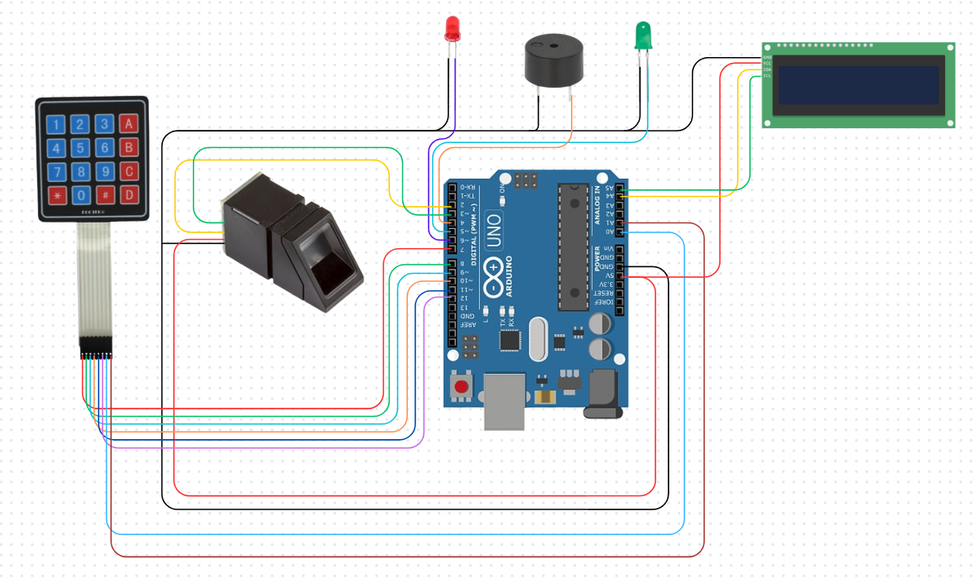

**Working Principle:**

1. On system start-up, the Arduino initializes all components including the fingerprint sensor and LCD.
2. The user places a finger on the sensor for scanning.
3. The fingerprint image is captured and compared with stored templates in the sensor's memory.
4. Based on the match result:
   * If matched:
     + Green LED turns ON.
     + LCD shows “Access Granted”.
     + Buzzer emits a short beep.
   * If not matched:
     + Red LED turns ON.
     + LCD shows “Access Denied”.
     + Buzzer beeps twice quickly.
5. The system resets and waits for the next fingerprint input.

**3.3 Software & Programming**

The system is programmed using the Arduino IDE with necessary libraries. Core programming features include:

* Initialization: Setup for the LCD, fingerprint sensor, and I/O pins.
* Fingerprint Enrollment: A separate program allows storage of fingerprint templates into the sensor's memory.
* Authentication Logic: Continuously checks for fingerprint input and processes authentication in real-time.
* Feedback Mechanism: Activates LEDs and buzzer based on success or failure.
* User Interface Display: Shows instructions and results using the I2C LCD.

Libraries Used:

* Adafruit Fingerprint for serial communication with the fingerprint module.
* LiquidCrystal_I2C for I2C-based LCD control.

**3.4 Structural Layout**

Though not mechanical in nature like a robotic car, the layout of components on a breadboard or PCB is crucial for clarity and accessibility:

* Component Mounting:
  + Arduino Uno and fingerprint sensor fixed to a project board or casing.
  + LCD panel visible at the front for user interaction.
  + LEDs and buzzer placed visibly for clear feedback.
* Wiring Management:
  + Neatly arranged jumpers to avoid short circuits.
  + Power and ground rails properly distributed.

This setup ensures compactness, portability, and ease of demonstration.

**Implementation & Testing**

**4.1 Fingerprint Module Calibration**

To ensure accurate biometric authentication and responsive operation, the fingerprint module undergoes thorough testing and calibration.

* Fingerprint Enrollment Testing:
  + Multiple fingerprints are enrolled into the sensor memory using the Arduino serial interface or a dedicated enrollment sketch.
  + Each enrolled fingerprint is verified for proper template creation and storage.
* Authentication Accuracy:
  + The module is tested with both enrolled and non-enrolled fingerprints.
  + Match success rate and false rejections/acceptance are monitored.
  + The fingerprint sensor is tested under different finger placements and pressure.
* Response Time Analysis:
  + The time taken from fingerprint placement to authentication response is measured.
  + Ensures real-time processing without noticeable delay.

**4.2 Component Feedback & Display Testing**

The system's feedback mechanism and user interface are tested for consistent and reliable behavior during operation.

* LED and Buzzer Response:
  + Red and Green LEDs are tested for proper triggering based on authentication result.
  + The buzzer is tested to emit:
    - A single beep for a successful scan.
    - Two short beeps for failed authentication.
* LCD Display Functionality:
  + The LCD is tested for backlight, clarity, and correctness of messages such as "Place Finger", "Access Granted", and "Access Denied".
  + I2C address compatibility and display refresh rate are verified.
  + Display remains legible under different lighting conditions.

**4.3 System Integration & Real-Time Testing**

All modules are tested together to validate the end-to-end functionality and robustness of the system.

* System Boot-up Sequence:
  + Upon power-up, the system initializes the fingerprint sensor, LCD, and feedback components correctly.
  + Startup messages on LCD confirm initialization.
* End-to-End Workflow Test:
  + The complete attendance logging process is tested from fingerprint input to final feedback output.
  + System handles multiple users in sequence without reset or lag.
* Stability Under Power Variations:
  + The system is tested using both USB and battery power sources.
  + Behavior under voltage drops is observed to ensure stability and reset prevention.
* User Usability Test:
  + The fingerprint scanning experience is evaluated for ease of use.
  + The system is tested by users with varying finger sizes and conditions (dry, oily, etc.).

**Challenges, Future Enhancements, Application & Conclusion**

# 5.1 Challenges & Limitations

# During the development and testing of the Biometric Attendance System, several challenges and limitations were encountered:

# Sensor Sensitivity & Accuracy:

# The fingerprint sensor may fail to recognize prints if fingers are wet, dirty, or scarred.

# Accuracy drops when users do not place their finger properly on the scanner.

# Limited Memory & Storage:

# The fingerprint module has a restricted number of storage slots for fingerprint templates.

# No built-in long-term data storage, making historical attendance tracking difficult.

# Power Stability & Reliability:

# Power fluctuations or low battery voltage may cause the system to reset or malfunction.

# A lack of battery backup or surge protection limits reliability in unstable environments.

# Component Integration & Compatibility:

# Ensuring seamless communication between Arduino, fingerprint sensor, and LCD requires careful wiring and library configuration.

# I2C address conflicts or library mismatches can disrupt LCD functionality.

# Lack of Real-Time Clock (RTC):

# Without an RTC, attendance logs cannot be timestamped, limiting their utility in formal environments.

# 5.2 Future Scope & Enhancements

# To improve the system’s usability, scalability, and robustness, several future enhancements are proposed:

# Data Logging & Storage Integration:

# Incorporate an EEPROM or SD card module for offline attendance storage.

# Enable CSV or log file export for institutional record-keeping.

# Real-Time Clock (RTC) Integration:

# Add an RTC module (e.g., DS3231) for date and time stamping of attendance logs.

# Useful for generating attendance reports and tracking trends over time.

# Wireless Connectivity & IoT:

# Upgrade to a Wi-Fi module (e.g., ESP8266) to sync attendance data with cloud servers or databases.

# Enable remote monitoring through a web dashboard or mobile app.

# Improved User Interface:

# Add a menu-driven LCD interface for administrators to enroll or delete fingerprints.

# Include a keypad or touch interface for enhanced interaction.

# Security Features:

# Implement multi-factor authentication by combining fingerprint scanning with a PIN code.

# Use encryption for data transmission and storage.

# 5.3 Applications of the Biometric Attendance System

# The project demonstrates practical applications in various real-world domains:

# Educational Institutions:

# Automated attendance logging in schools, colleges, and coaching centers.

# Reduces manual errors and proxy attendance.

# Offices and Workplaces:

# Employee attendance monitoring for HR and payroll management.

# Secure access control to restricted areas.

# Research Labs and Libraries:

# Regulated access to sensitive equipment or materials.

# Tracks entry/exit times for accountability.

# Healthcare & Clinical Facilities:

# Records staff attendance in high-security or sterile zones.

# Reduces contact-based logging methods in hygienic environments.

# Public Sector and Government Use:

# Time-tracking for public servants and contract workers.

# Transparent, auditable logs for administration.

# 5.4 Conclusion

# The Biometric Attendance System is a compact, cost-effective solution that leverages fingerprint recognition for secure and automated attendance logging. Built using Arduino and readily available components, it offers a scalable prototype ideal for learning and practical deployment.

# Despite its current limitations—such as storage constraints and lack of time tracking—the system lays a strong foundation for further innovation. Future enhancements including data logging, real-time clocks, and cloud integration can significantly elevate its utility and robustness.

# With continued development, the project holds potential for wide adoption across academic, corporate, and institutional settings, contributing to smarter, more secure access and attendance management systems.